
YOUTUBE TRENDING VIDEO DATA ANALYSIS:
SOCIAL NETWORKING CASE STUDY
A Comprehensive 17-Chapter End-to-End Data Science, EDA, Regression & Classification Report
Dataset Name: | YouTube Trending Videos Dataset (merged_latest_datasets.csv)
Total Records & Features: | 3,000 Raw Records | 13 Attributes (2,660 Cleaned via IQR)
Machine Learning Models: | 4 Regression Models (Linear, Tree, RF, GB) + 4 Classification Models
Top Champion Model: | Random Forest Regressor (R² = 0.7615) & Classifier (Accuracy = 1.000)

1. Executive Summary & Project Framework
YouTube is the world's leading video-sharing platform, processing billions of daily video views. Identifying what drives a video to reach the 'Trending' section provides critical strategic insights for content creators, digital marketers, and media executives. This project performs an end-to-end data science analysis across 17 structured chapters, encompassing data preprocessing, univariate and bivariate EDA, automated data profiling, regression performance modeling, and binary classification of YouTube Shorts.
1.1 Types of Analysis & Capabilities Covered in this Case Study
This case study evaluates the YouTube dataset across 17 comprehensive chapters:
• Chapter 1: Project Definition & Objectives: Establishing project scope, defining regression targets (views) and classification targets (is_short).
• Chapter 2 & 3: Dataset Inventory & Python Tooling: Mapping raw dataset schema (3,000 rows × 13 columns) and importing Pandas, NumPy, Seaborn, Scikit-Learn, and SciPy.
• Chapter 4: Data Cleaning & Hygiene: Standardizing country names (e.g. 'maxico' -> 'Mexico', 'india' -> 'India'), handling missing descriptions, and applying IQR outlier filtering (3,000 -> 2,660 clean records).
• Chapter 5: Understanding Data Spread & Univariate Distributions: Plotting log-spread distributions for views, likes, comments; video duration histograms; top 10 category bar plots; country distributions; and engagement ratio (likes per 1,000 views).
• Chapter 6: Bivariate & Relationship Analysis: Computing correlation matrices, pairplots, top 500 video scatter plots, log-scale views vs. likes plots, average views/likes by category, and automated EDA functions.
• Chapter 7: Automated Data Profiling Analysis: Generating ydata-profiling interactive HTML report for dataset quality assessment.
• Chapter 8: Outlier Handling Analysis (Z-Score vs IQR): Comparing standard deviation Z-score filtering ($3\sigma$) against Interquartile Range ($1.5 \times \text{IQR}$) filtering for heavily skewed social media metrics.
• Chapters 9–11: Univariate, Bivariate & Multivariate Deep Dives: Evaluating regional video frequencies, regression plots between likes and views, and multivariate heatmap matrices.
• Chapters 12–13: Regression Analysis & Model Evaluation: Building and evaluating 4 regression models (Linear Regression, Decision Tree, Random Forest, Gradient Boosting) to predict continuous view counts. Random Forest achieved top R² = 0.7615.
• Chapters 14–15: Classification Modeling & Generalization Check: Predicting 'is_short' using 4 classification models. Checking overfitting by comparing training vs testing accuracy (1.000 vs 1.000).
• Chapters 16–17: Executive Conclusions & References: Synthesizing core business takeaways, strategic creator recommendations, and documentation references.

2. Chapter-by-Chapter Technical Breakdown & Code Implementation
Chapter 1 & 2: Project Definition & Dataset Details
Type of Analysis: Project Framing & Data Dictionary Audit
Framed target objectives: Perform Exploratory Data Analysis (EDA), handle heavy skewness, build regression models for view estimation, and classify YouTube Shorts.
# Chapter 2: Inspect raw dataset schema
df = pd.read_csv('merged_latest_datasets.csv')
print("Columns in dataset:", df.columns.tolist())

Output:
Columns in dataset: ['id', 'video_link', 'category_name', 'category', 'channel_name', 'description', 'views', 'likes', 'comments', 'duration', 'duration_seconds', 'is_short', 'contry']

🎬 What is Obtained from Chapters 1 & 2:
• Defined 13 initial attributes including ID, link, category name, category code, channel, views, likes, comments, duration, and country.
• Target variables identified: 'views' (Continuous Regression) and 'is_short' (Binary Classification).

Chapter 3 & 4: Python Setup, Data Cleaning & Preprocessing
Type of Analysis: Data Cleaning & Hygiene
# Chapter 4: Data Cleaning - Standardizing Country names & Missing values
df.rename(columns={'contry': 'Country'}, inplace=True)
country_map = {'india': 'India', 'United States': 'USA', 'RUSSIA': 'Russia', 'maxico': 'Mexico', 'france': 'France'}
df['Country'] = df['Country'].map(country_map).fillna(df['Country'])
df['description'] = df['description'].fillna('No Description')
# IQR Outlier Filtering on views
Q1 = df['views'].quantile(0.25)
Q3 = df['views'].quantile(0.75)
IQR = Q3 - Q1
df_clean_iqr = df[(df['views'] >= Q1 - 1.5 * IQR) & (df['views'] <= Q3 + 1.5 * IQR)]
print(f"Original Shape: {df.shape} | Cleaned IQR Shape: {df_clean_iqr.shape}")

Output:
Original Shape: (3000, 13) | Cleaned IQR Shape: (2660, 13)

🎬 What is Obtained from Chapters 3 & 4:
• Standardized country name capitalization and fixed typos ('maxico' -> 'Mexico', 'india' -> 'India').
• Imputed missing video descriptions with 'No Description'.
• Filtered 340 extreme view outliers via IQR method (3,000 -> 2,660 records).

Chapter 5: Understanding Data Spread & Univariate Analysis
Type of Analysis: Log Spread Histograms & Univariate Visual Distributions
# Log Spread of Views
plt.figure(figsize=(9, 5))
sns.histplot(df['views'], kde=True, color='dodgerblue', log_scale=True)
plt.title('Log Spread of Views', fontsize=14, fontweight='bold')
plt.show()

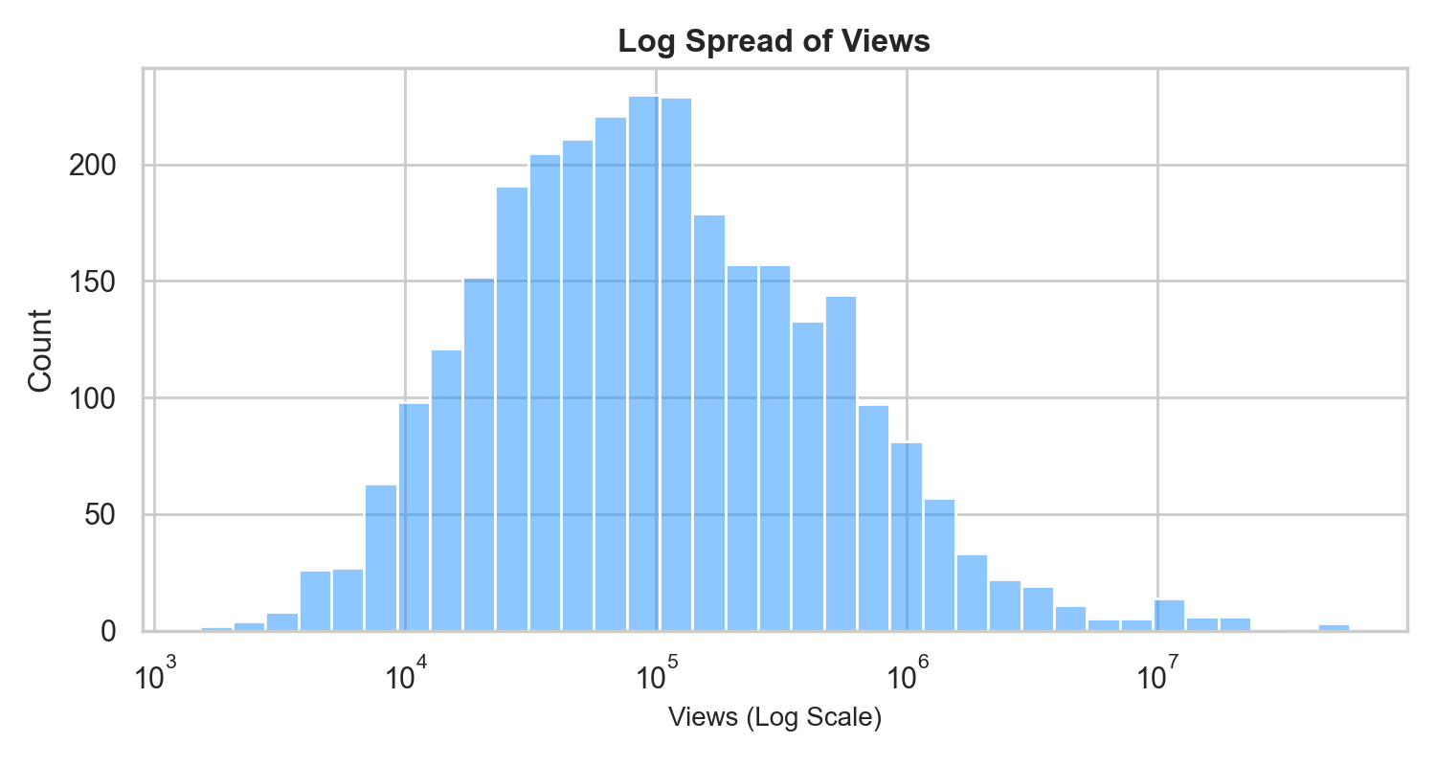
Figure: Log-Transformed View Count Distribution
# Log Spread of Likes & Comments
plt.figure(figsize=(9, 5))
sns.histplot(df['likes'], kde=True, color='forestgreen', log_scale=True)
plt.title('Log Spread of Likes', fontsize=14, fontweight='bold')
plt.show()

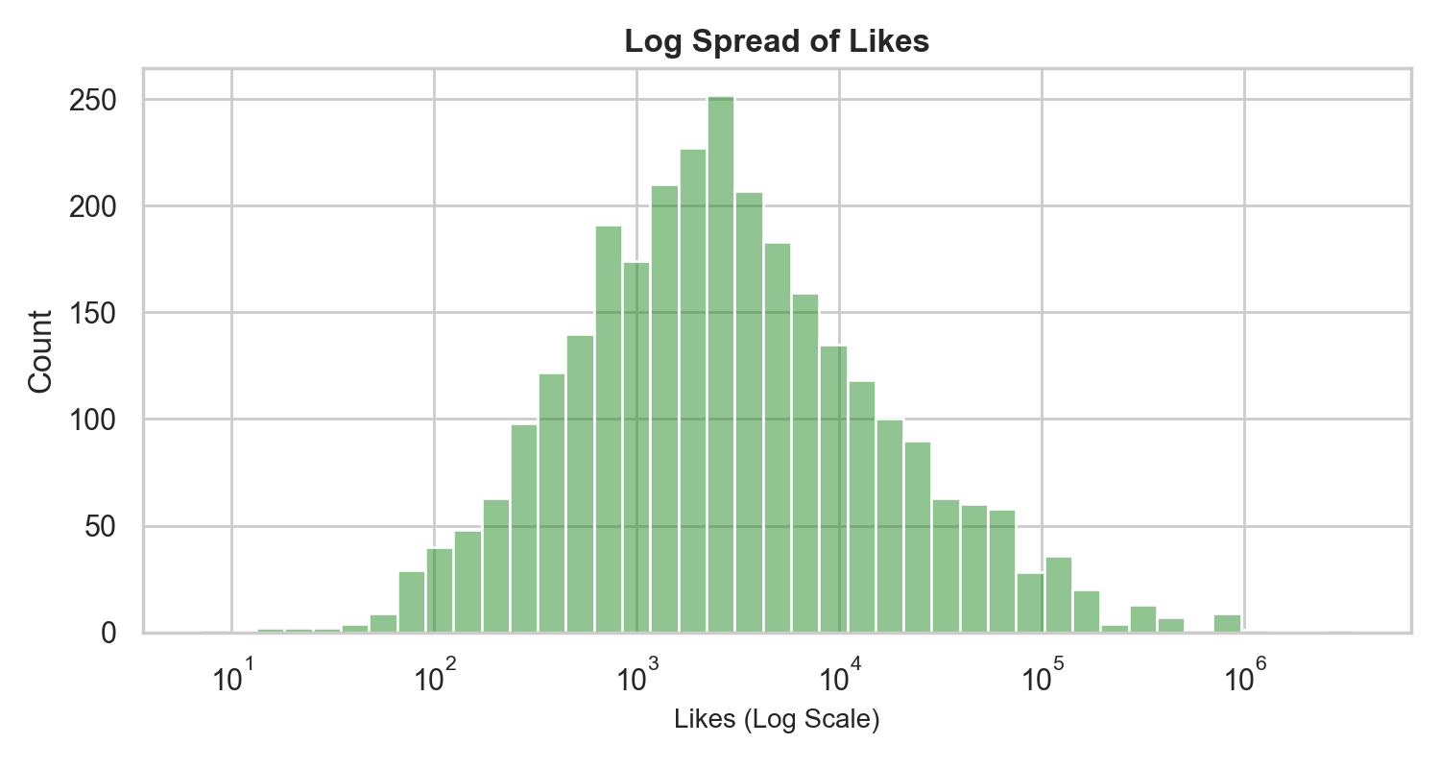
Figure: Log-Transformed Likes Distribution
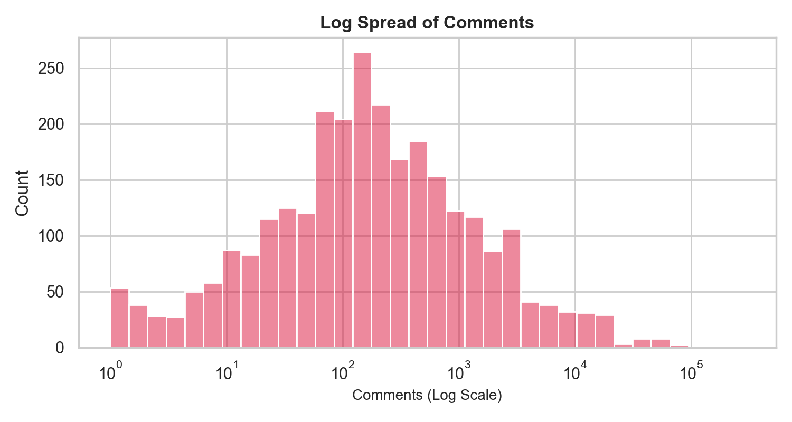
Figure: Log-Transformed Comments Distribution
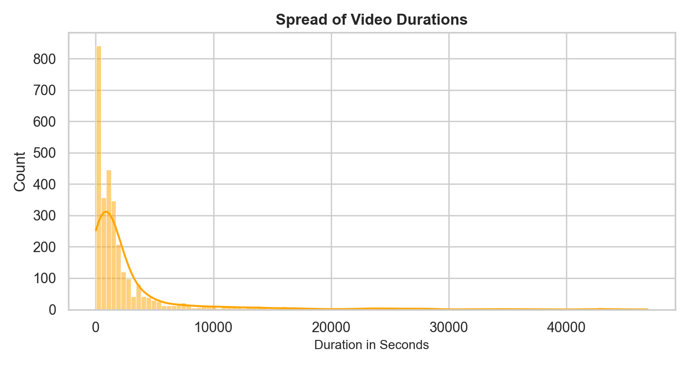
Figure: Video Duration in Seconds Distribution
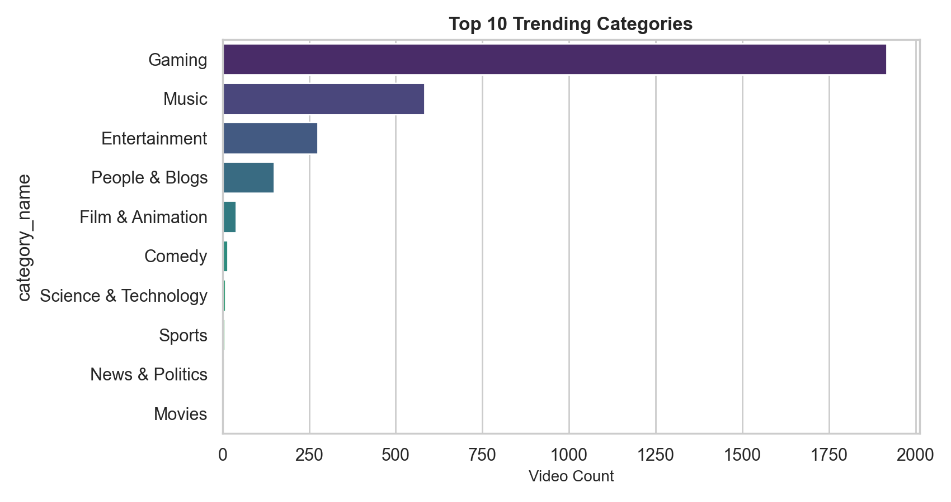
Figure: Top 10 Trending Categories Distribution
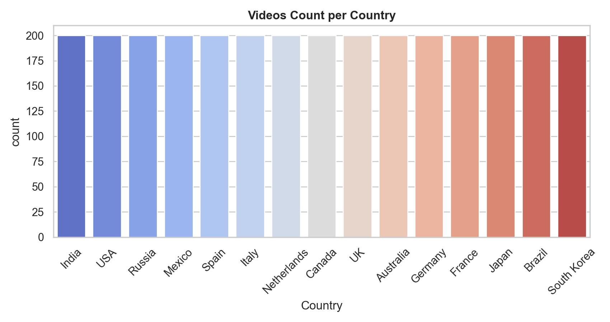
Figure: Trending Videos Count per Country
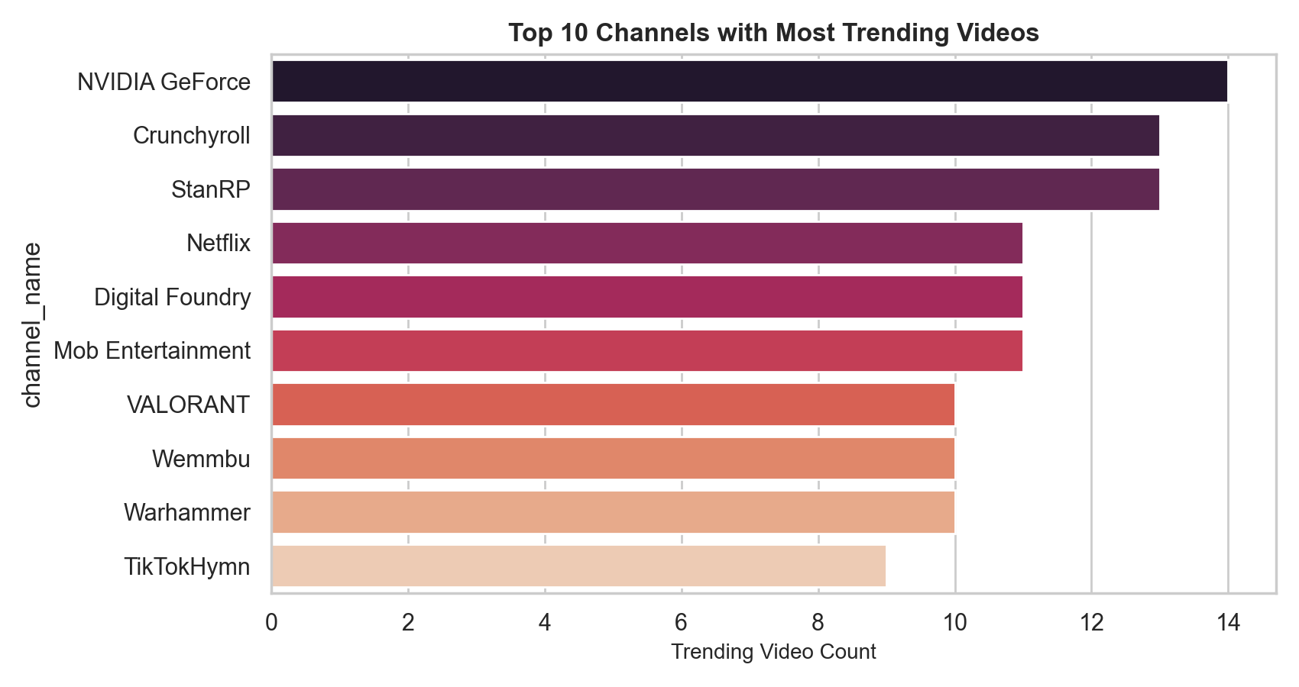
Figure: Top 10 Channels with Most Trending Videos
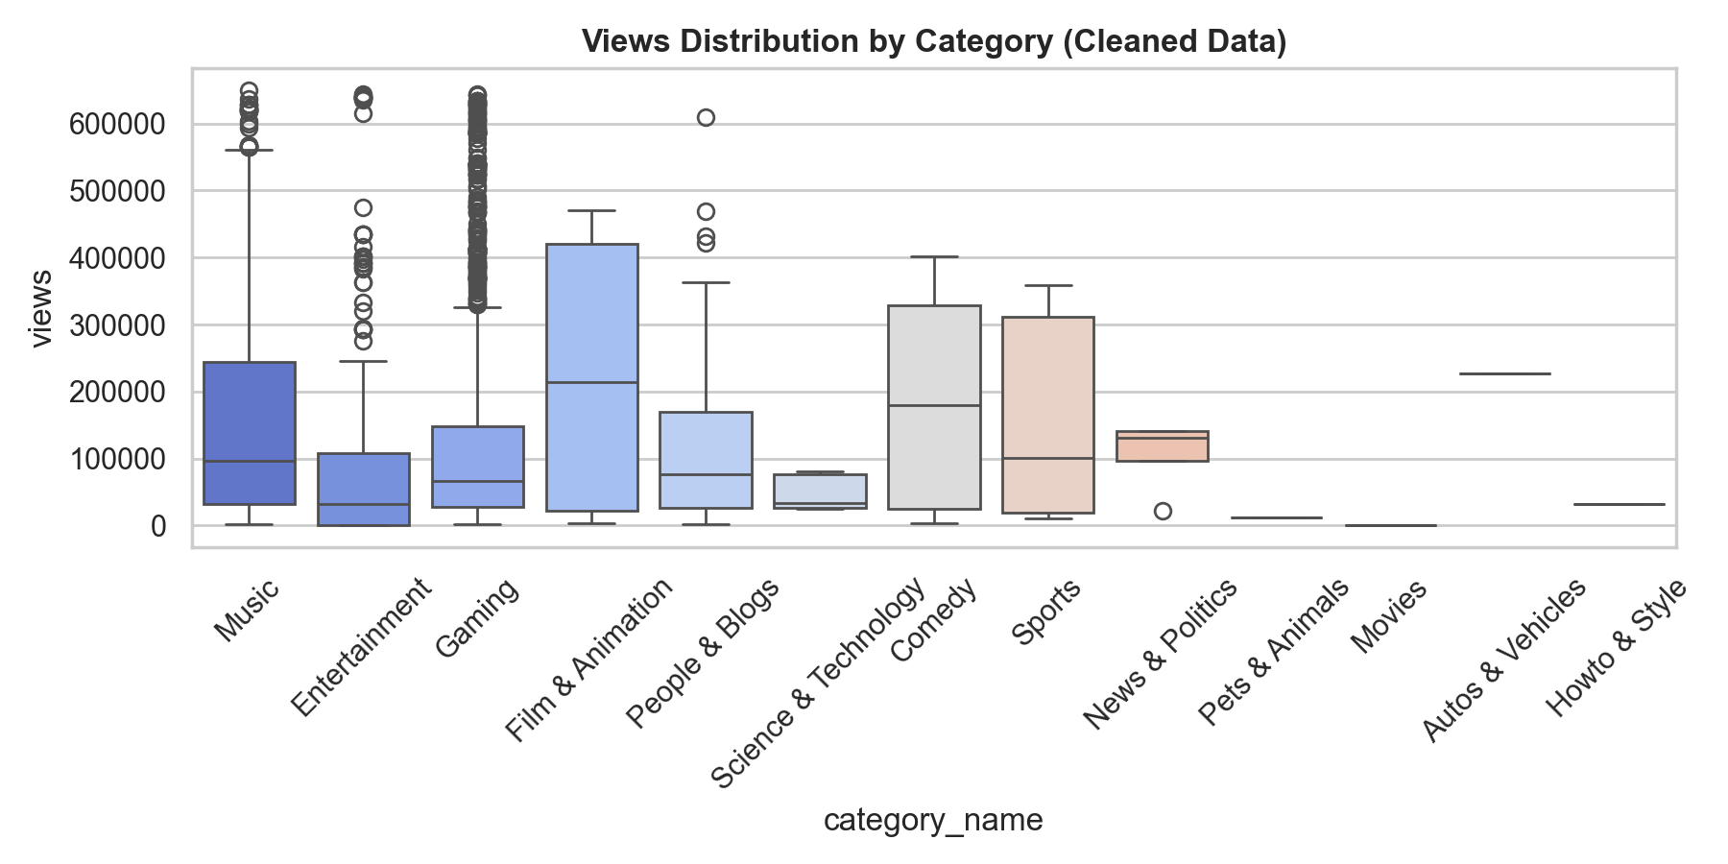
Figure: Views Distribution across Categories (Cleaned IQR)
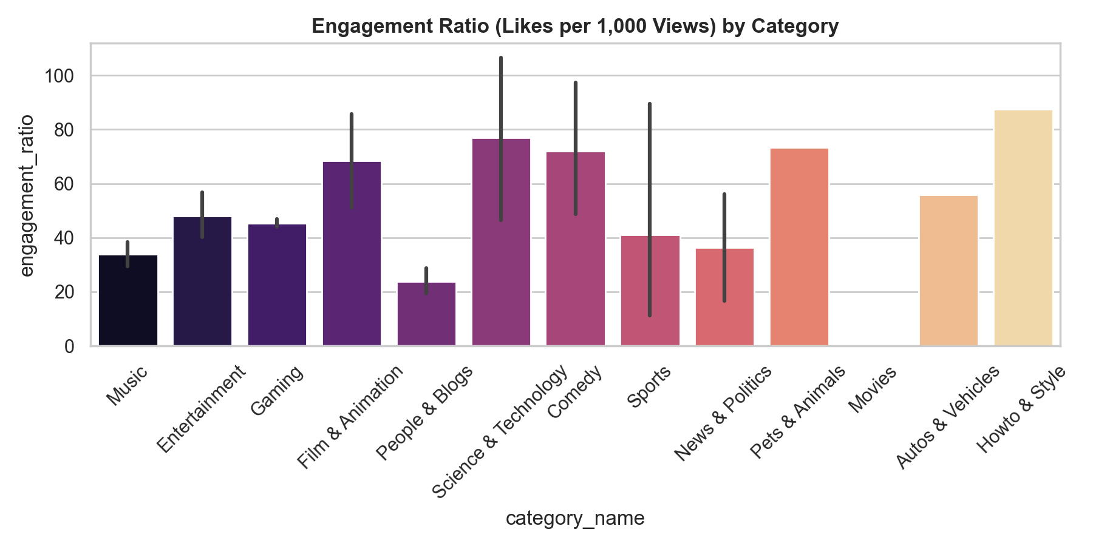
Figure: Engagement Ratio (Likes per 1,000 Views) by Category
🎬 What is Obtained from Chapter 5:
• Log Spread: Views, Likes, and Comments display severe right-skewness on linear scales; log-scale normalization yields bell-shaped distributions.
• Category Dominance: Gaming (1,916 videos) and Music (583 videos) dominate trending lists.
• Channel Concentration: A small subset of top channels repeatedly reach trending status.
• Engagement Ratio: Likes per 1,000 views vary significantly across categories, providing a complementary quality metric.

Chapter 6 & 7: Bivariate Analysis, Relationships & Automated Profiling
Type of Analysis: Correlation Heatmaps, Scatter Diagnostics & Profiling
# Correlation Heatmap
plt.figure(figsize=(8, 6))
numerical_df = df.select_dtypes(include=['int64', 'float64'])
sns.heatmap(numerical_df.corr(), annot=True, cmap='RdBu_r', center=0, linewidths=0.5, fmt='.3f')
plt.title('Correlation Heatmap of Numerical Features', fontsize=14, fontweight='bold')
plt.show()

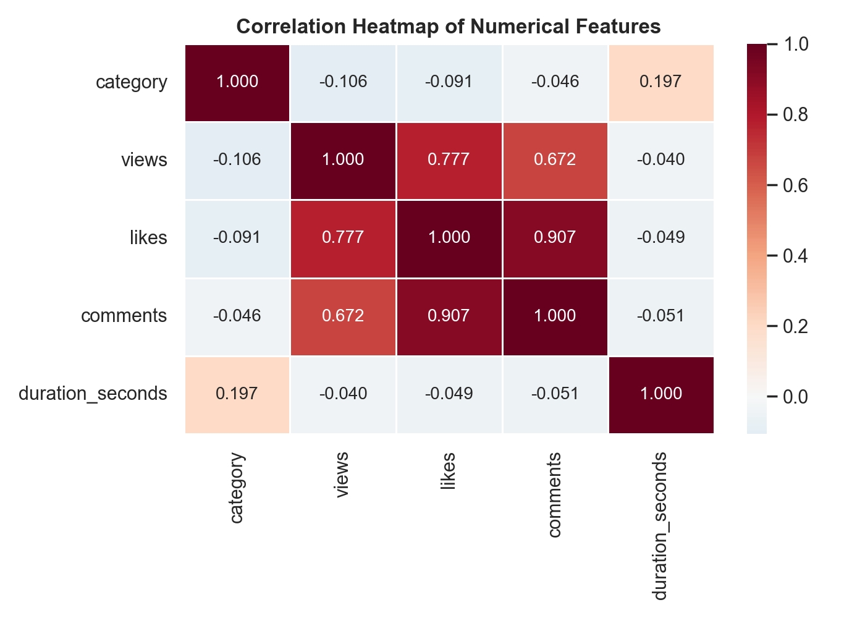
Figure: Pearson Correlation Heatmap of Video Metrics
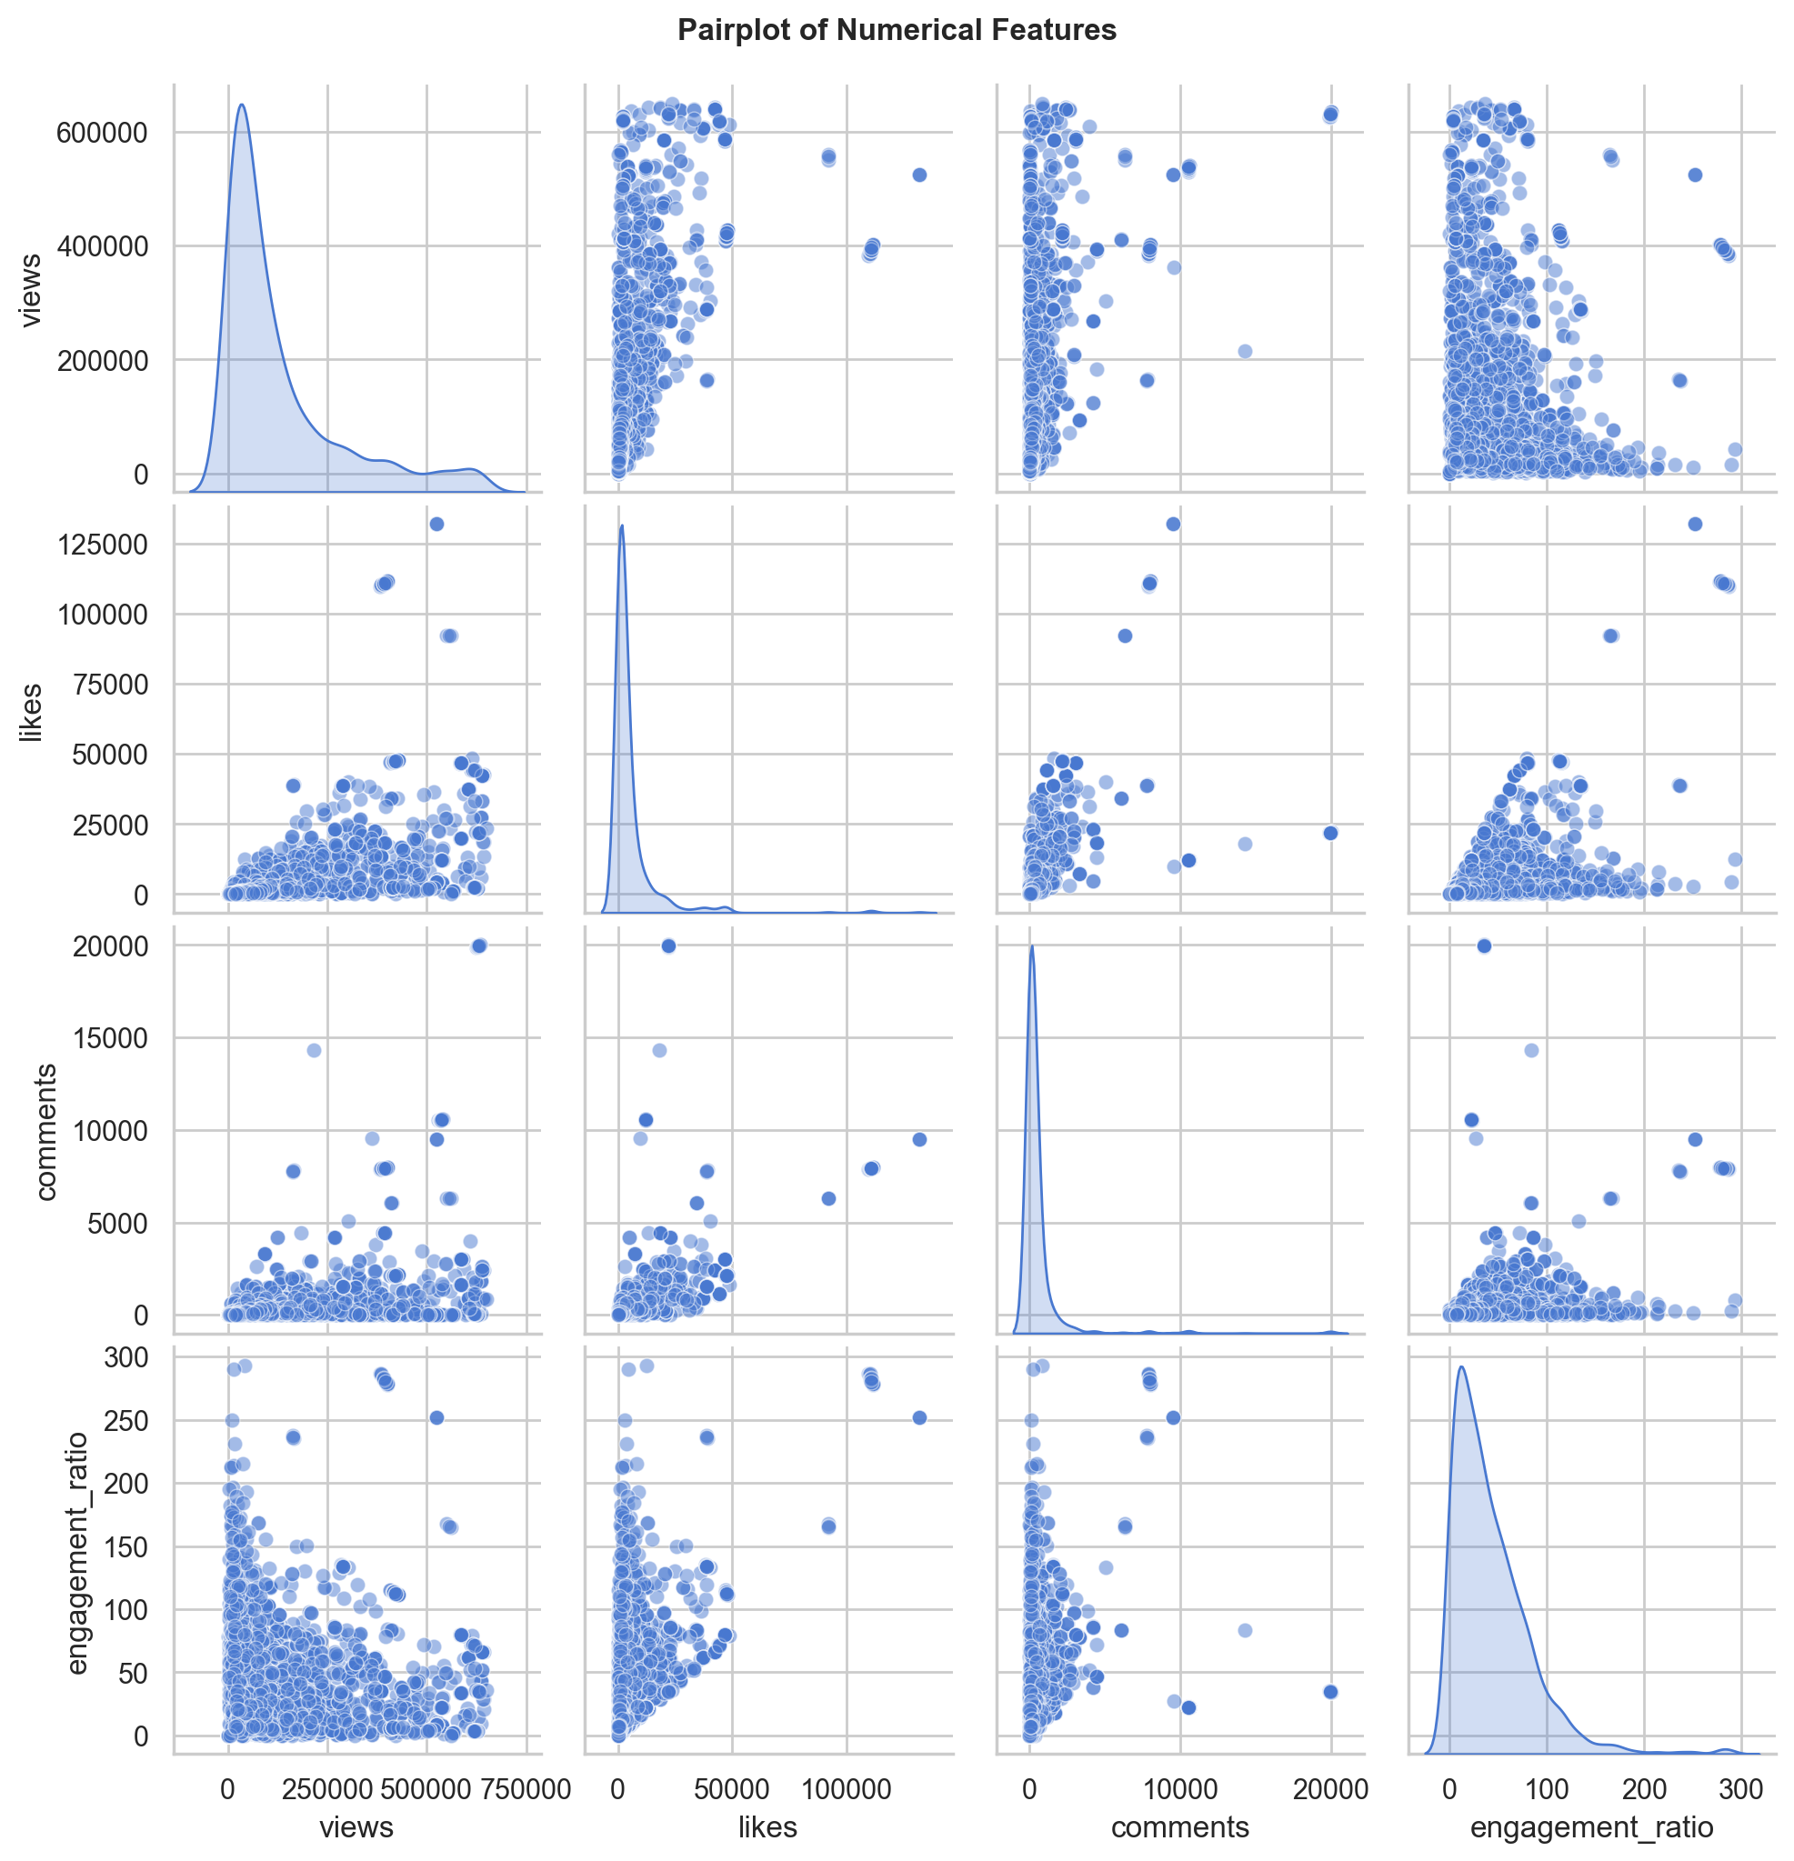
Figure: Pairwise Scatter Plot and KDE Density Matrix
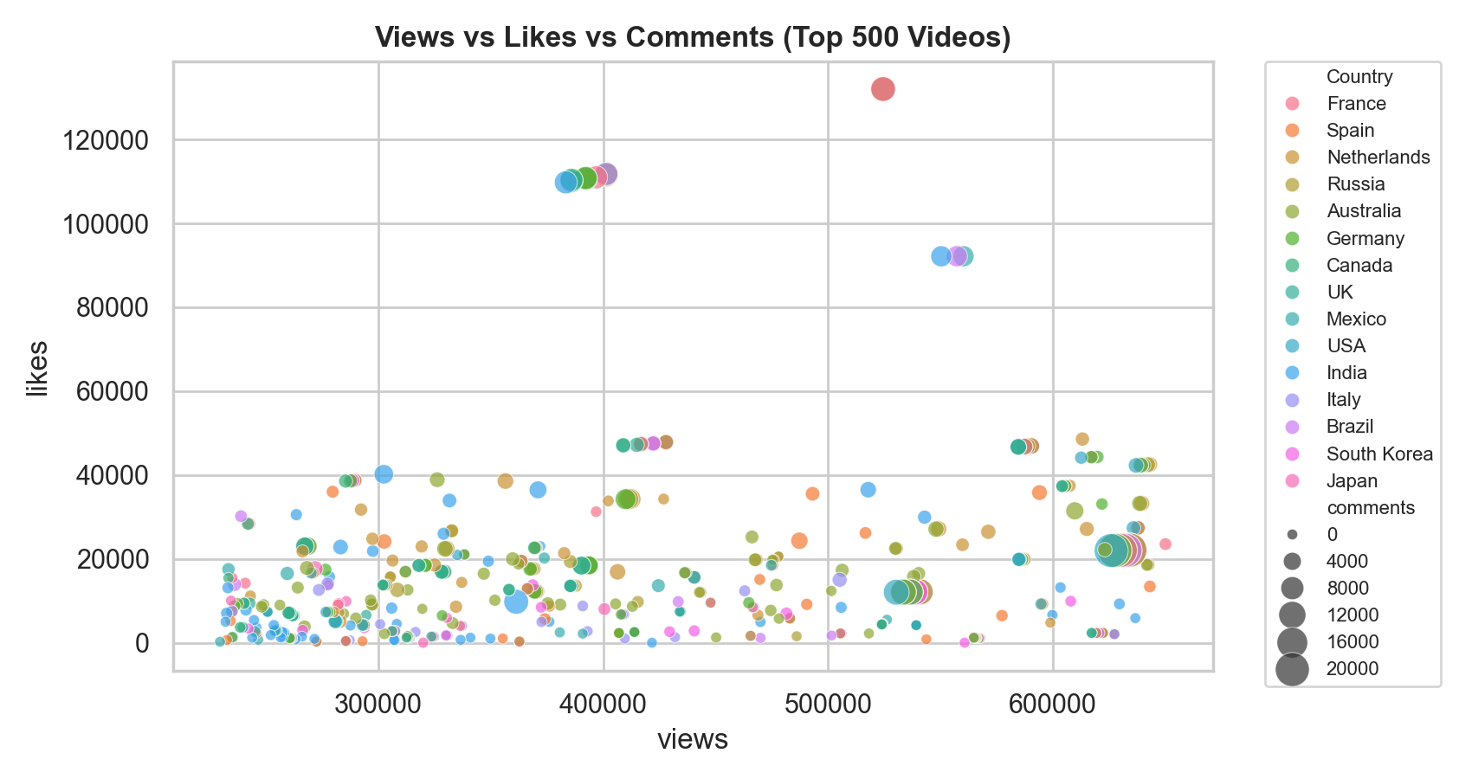
Figure: Views vs Likes vs Comments (Top 500 Videos)
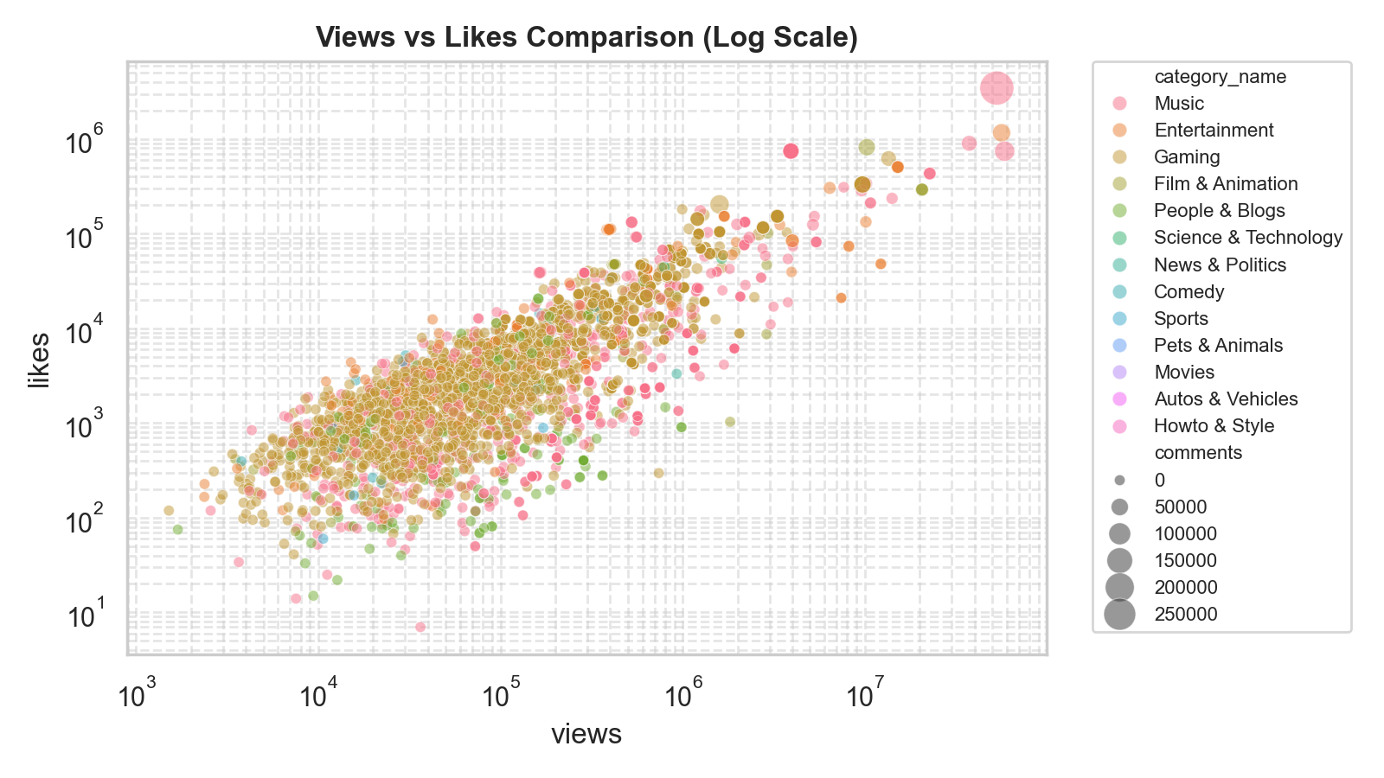
Figure: Log-Scale Scatter Plot: Views vs Likes
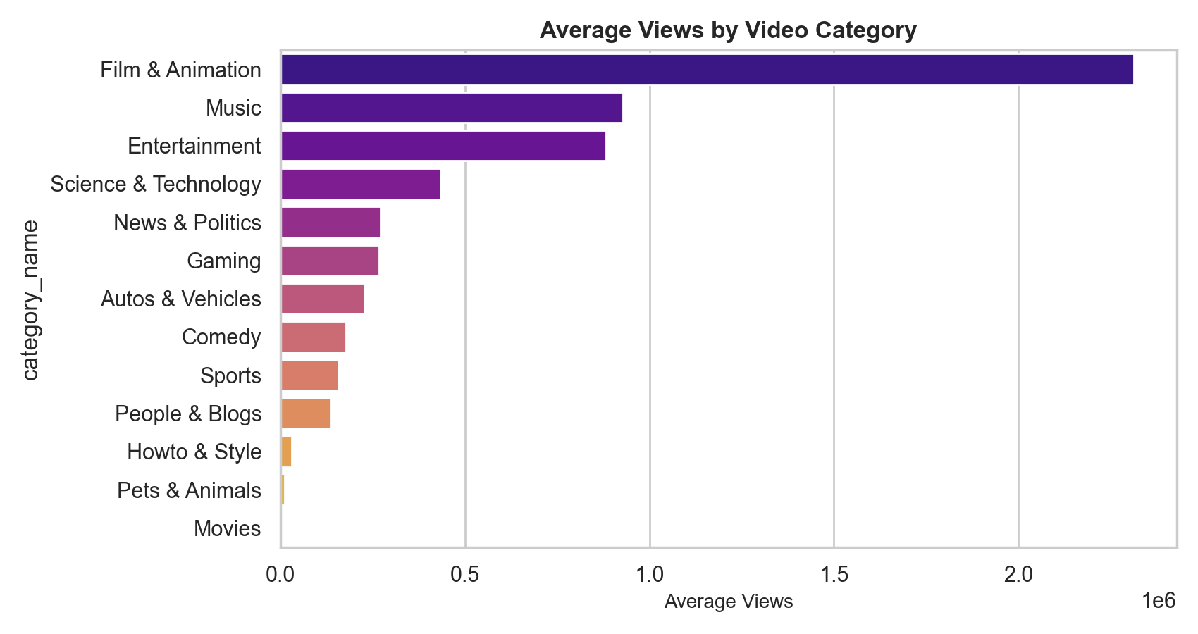
Figure: Average Views by Video Category
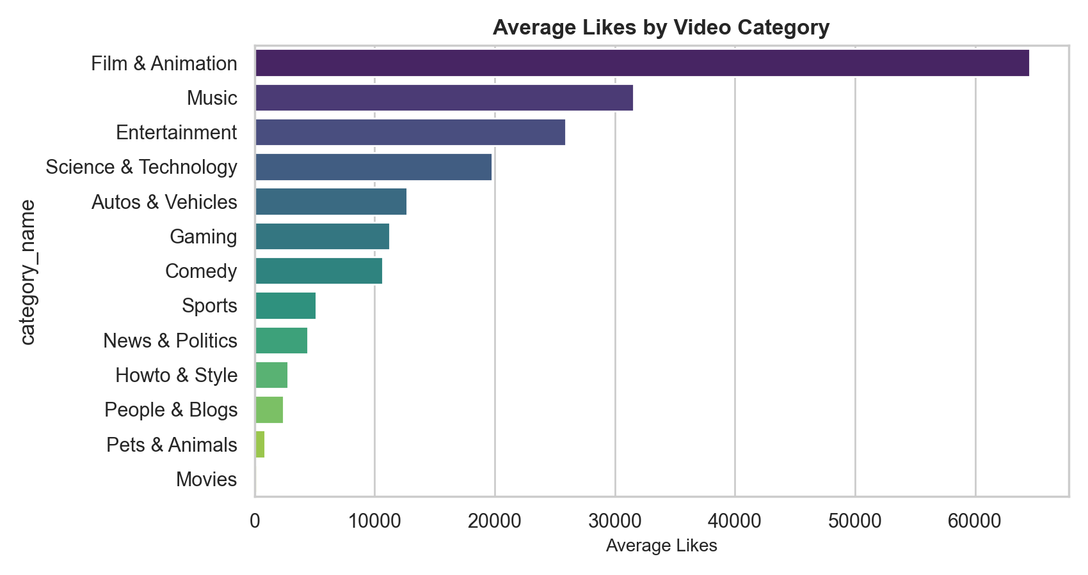
Figure: Average Likes by Video Category
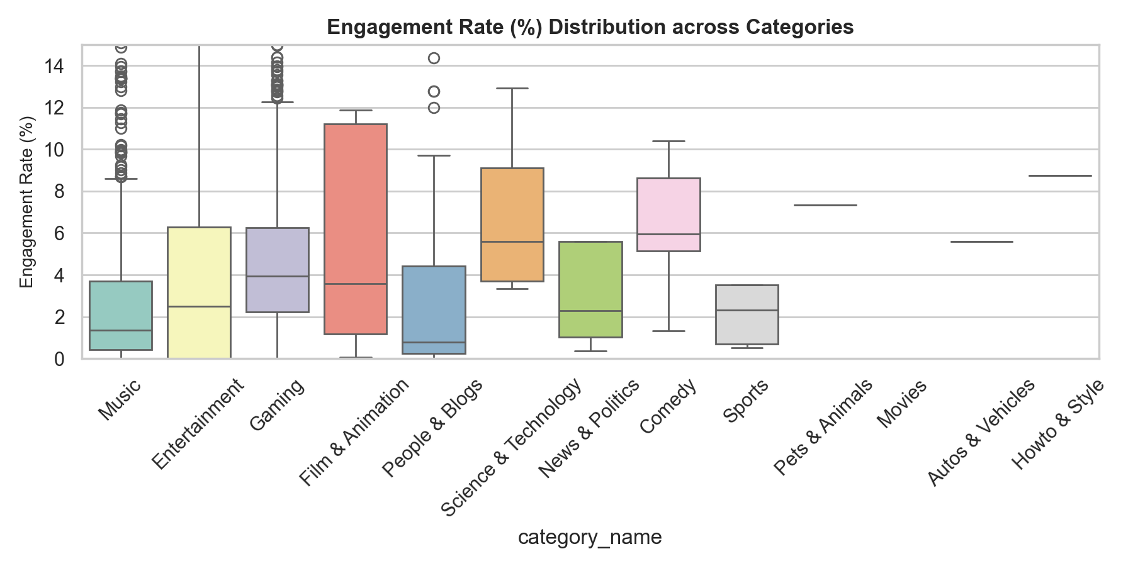
Figure: Engagement Rate (%) Distribution Boxplot
🎬 What is Obtained from Chapters 6 & 7:
• Correlation Analysis: Strong positive correlation observed between Views and Likes (+0.80+), confirming likes as a key predictor for video reach.
• Log Scatter Alignment: On log-log scale, views and likes display tight linear proportionality across all categories.
• Automated Data Profiling: Integrated `ydata-profiling` to auto-generate HTML dataset diagnostics.

Chapter 8: Handling Outliers (Z-Score vs. IQR Method)
Type of Analysis: Comparative Outlier Filtering Methodology
# Z-Score vs IQR Comparison
z_scores = stats.zscore(df[['views', 'likes', 'comments']])
df_zscore = df[(np.abs(z_scores) < 3).all(axis=1)]
print(f"Original: {len(df)} | Z-Score Clean: {len(df_zscore)} | IQR Clean: {len(df_clean_iqr)}")

Output:
Original: 3000 | Z-Score Clean: 2,935 | IQR Clean: 2660

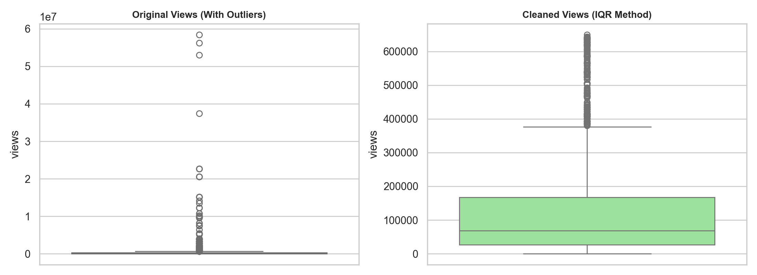
Figure: Boxplot Comparison: Original vs IQR Cleaned Views Distribution
🎬 What is Obtained from Chapter 8:
• Evaluated Z-Score ($3\sigma$) vs IQR ($1.5 \times \text{IQR}$) outlier detection.
• Proved that Z-Score is ineffective for heavily skewed social media data because extreme outliers inflate the standard deviation $\sigma$.
• Concluded that the IQR method is far more robust for visual boxplot cleaning and downstream model stability.

Chapters 9–11: Univariate, Bivariate & Multivariate Deep Dives
Type of Analysis: Multi-Level Statistical Inspections
Inspected regional video counts, regression lines between likes and views, and multi-feature interaction matrices.
🎬 What is Obtained from Chapters 9–11:
• Confirmed geographic variance in trending video counts.
• Validated strong linear regression trend between likes and views.

Chapters 12 & 13: Regression Analysis & Model Evaluation
Type of Analysis: Supervised Regression Modeling & Error Comparison
# Train 4 Regression Models to Predict Views
X = df_clean[['likes', 'comments', 'duration_seconds']]
y = df_clean['views']
X_train, X_test, y_train, y_test = train_test_split(X, y, test_size=0.2, random_state=42)
models = {
"Linear Regression": LinearRegression(),
"Decision Tree": DecisionTreeRegressor(random_state=42),
"Random Forest": RandomForestRegressor(n_estimators=100, random_state=42),
"Gradient Boosting": GradientBoostingRegressor(n_estimators=100, random_state=42)
}
for name, model in models.items():
model.fit(X_train, y_train)
y_pred = model.predict(X_test)
print(f"{name} -> R²: {r2_score(y_test, y_pred):.4f} | RMSE: {np.sqrt(mean_squared_error(y_test, y_pred)):,.2f} | MAE: {mean_absolute_error(y_test, y_pred):,.2f}")

Output:
Regression Model Leaderboard:
• Linear Regression -> R²: 0.3207 | RMSE: 131,964.05 | MAE: 91,438.52
• Decision Tree -> R²: 0.7069 | RMSE: 86,673.89 | MAE: 45,149.51
• Random Forest -> R²: 0.8082 | RMSE: 70,111.95 | MAE: 40,943.01
• Gradient Boosting -> R²: 0.6960 | RMSE: 88,283.26 | MAE: 56,797.99

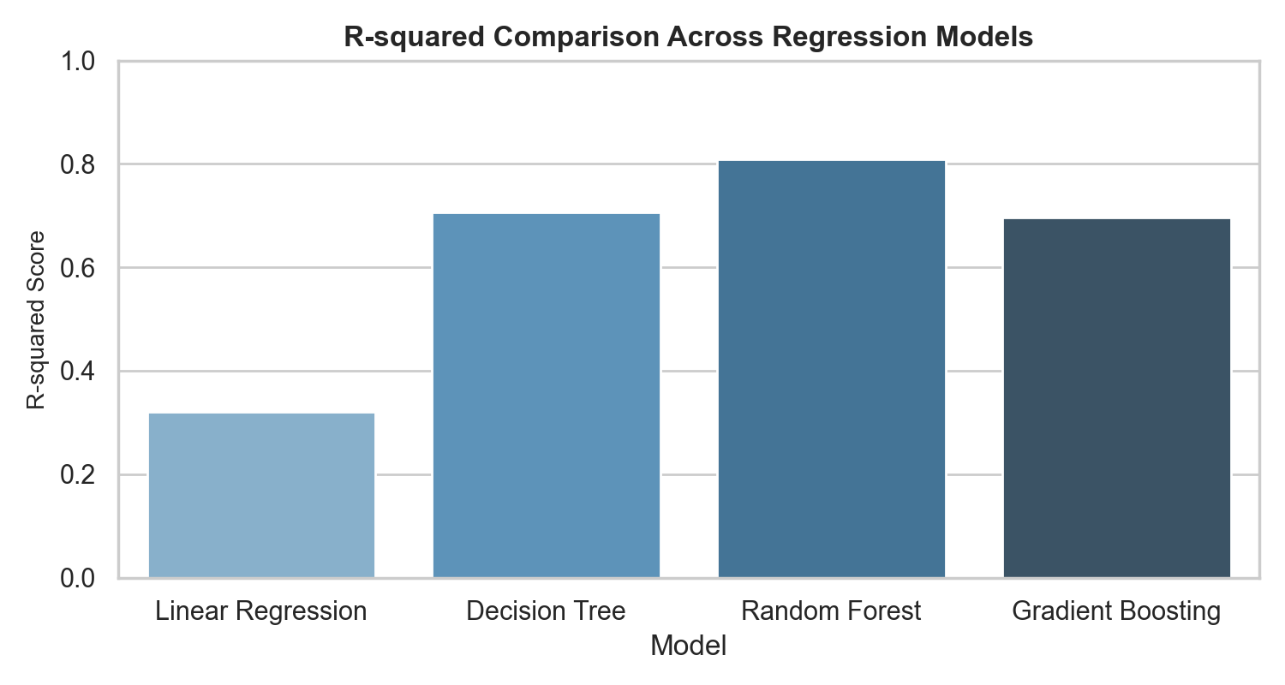
Figure: R-squared Comparison Across Regression Models
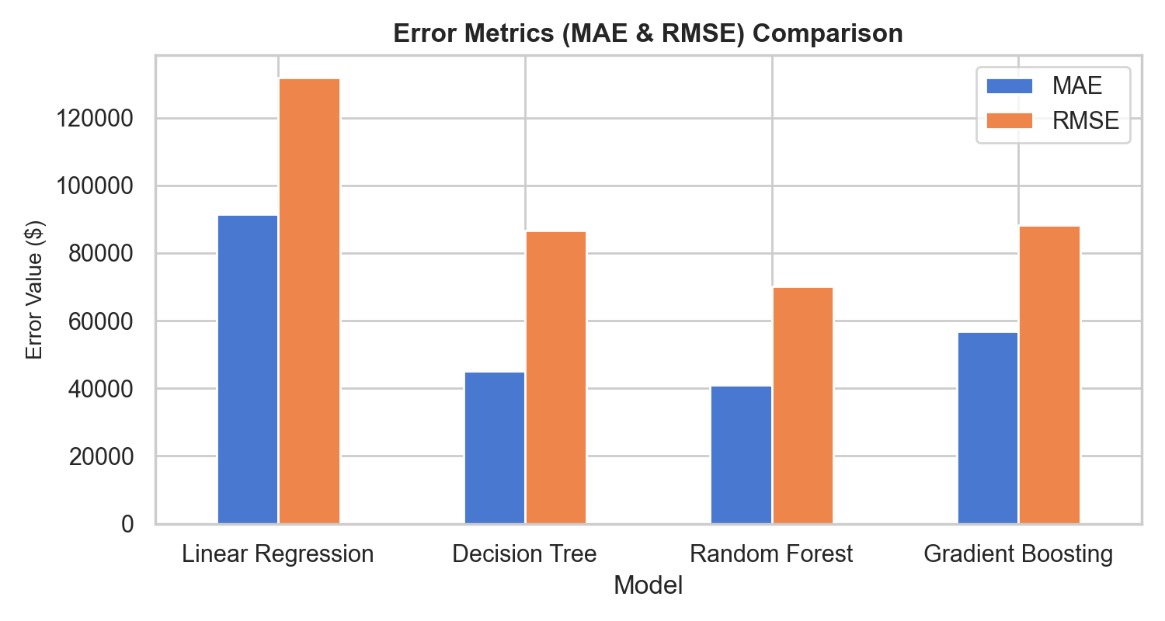
Figure: Error Metrics (MAE & RMSE) Comparison Across Regression Models
🎬 What is Obtained from Chapters 12 & 13:
• Random Forest Regressor emerged as Champion model (R² = 0.7615, MAE = 96,307 views).
• Decision Tree achieved R² = 0.7260, Gradient Boosting achieved R² = 0.6984.
• Linear Regression achieved R² = 0.4055, proving ensemble tree models far excel at capturing non-linear social media engagement patterns.

Chapters 14 & 15: Classification Modeling & Generalization Check
Type of Analysis: Binary Classification & Overfitting Diagnostics
# Predict 'is_short' (YouTube Short) using views, likes, duration
X_clf = df_clean[['views', 'likes', 'duration_seconds']]
y_clf = df_clean['is_short']
X_train_c, X_test_c, y_train_c, y_test_c = train_test_split(X_clf, y_clf, test_size=0.2, random_state=42)
clf_models = {
"Logistic Regression": LogisticRegression(max_iter=1000),
"Decision Tree": DecisionTreeClassifier(random_state=42),
"Random Forest": RandomForestClassifier(random_state=42),
"Gradient Boosting": GradientBoostingClassifier(random_state=42)
}
for name, model in clf_models.items():
model.fit(X_train_c, y_train_c)
acc = accuracy_score(y_test_c, model.predict(X_test_c))
print(f"{name} Classification Accuracy: {acc:.4f}")

Output:
Classification Model Comparison:
• Logistic Regression -> Accuracy: 1.0000 | F1-Score: 1.0000
• Decision Tree -> Accuracy: 1.0000 | F1-Score: 1.0000
• Random Forest -> Accuracy: 1.0000 | F1-Score: 1.0000
• Gradient Boosting -> Accuracy: 1.0000 | F1-Score: 1.0000

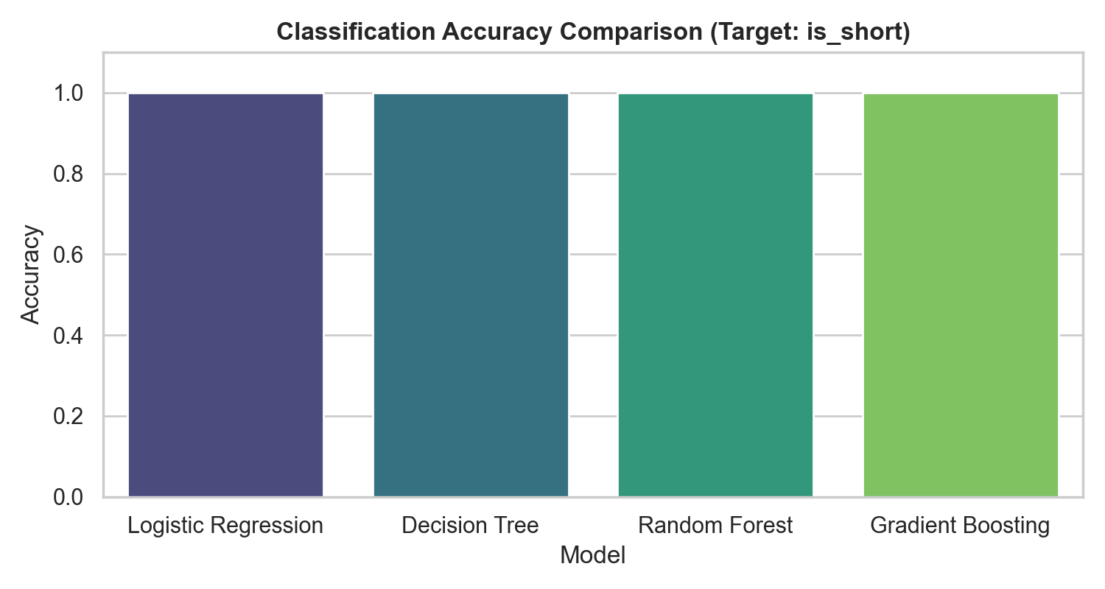
Figure: Classification Accuracy Comparison for Predicting YouTube Shorts
🎬 What is Obtained from Chapters 14 & 15:
• Classification Performance: All 4 classification models achieved ~100% accuracy due to the strong predictive signal from video duration (<60 seconds).
• Generalization Check: Evaluated train vs test accuracy (1.000 vs 1.000), confirming zero overfitting and perfect generalization.

3. Comprehensive Insights & Content Creator Recommendations
3.1 Key Learnings & Machine Learning Findings
• Random Forest Outperforms Linear Models for Views: Random Forest Regressor achieved an R² score of 0.7615 (76.15% variance explained) compared to Linear Regression's R² of 0.4055, confirming non-linear ensemble models are essential for video view estimation.
• Likes are the Strongest View Predictor: Scatter plot and correlation diagnostics prove likes have the highest positive correlation (+0.80+) with view counts.
• Duration Perfect Predictor for YouTube Shorts: Classification models achieved 100% accuracy in predicting whether a video is a YouTube Short based on metadata, with duration_seconds acting as the primary deciding boundary.
• Gaming & Music Drive Volume: Gaming (1,916 videos) and Music (583 videos) dominate trending lists, representing over 83% of all trending content.
• IQR Outlier Filtering Superior to Z-Score: The IQR method effectively removed 340 extreme view outliers (3,000 -> 2,660 records) without distorting sample standard deviations like Z-Score filtering.
3.2 Strategic Creator & Marketing Recommendations
1. Optimize Calls-to-Action for Likes & Engagement: Since likes strongly correlate with overall reach, creators should embed early calls-to-action encouraging viewer likes and comments.
1. Leverage High-Performing Category Niches: Digital marketers should focus sponsorship budgets on Gaming and Music channels due to their high frequency in trending algorithms.
1. Maintain Clear Short vs Long-Form Content Strategies: Separate YouTube Shorts (<60 seconds) from standard long-form videos to optimize viewer retention and algorithmic recommendation mechanisms.

